Reporting in AmpliFund

Log into AmpliFund and Select “Grants” in Grant Management Navigation Bar

Under selected grant, select “Post-Award”, then “Performance”, then “Performance Plan”.

Under each Goal you will see a Trophy Icon . Select this icon to enter your quarterly progress related to each goal.
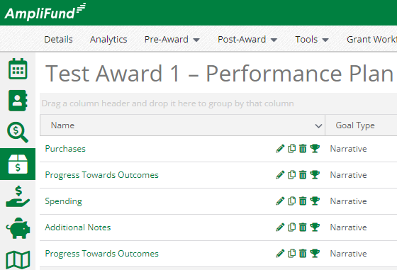

Create a new “Achievement” by selecting the add button.
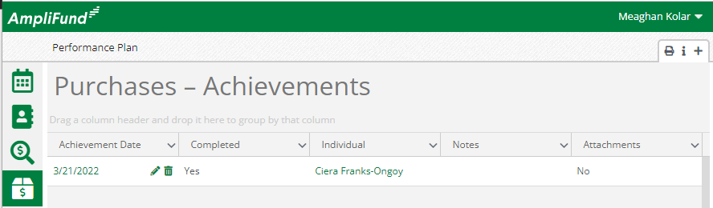

Enter the “Achievement Date” (this date will be between the dates of the quarter being reported on – e.g. Quarter 1 dates are July 1 – September 30).
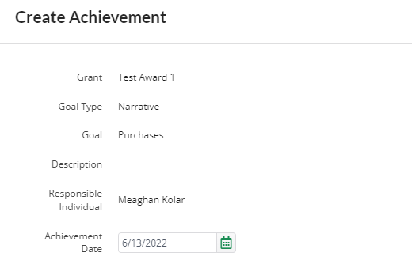

Enter Answer to Goal Question in the text box. If goal is complete select the “Complete” box, upload files if necessary and select “Create”.
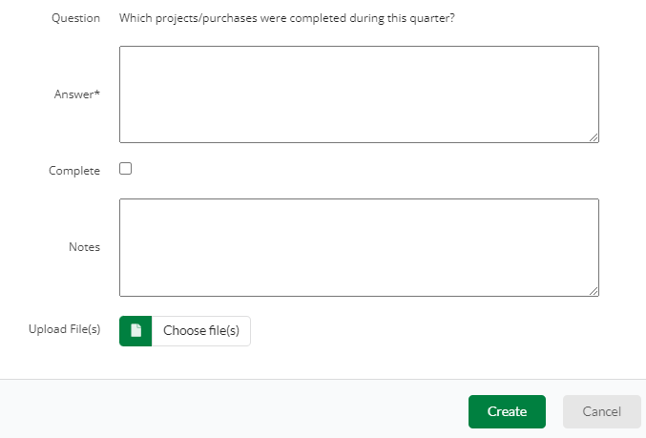
Text Here

