Table of Contents
Table of Contents 1
Forms Used When Preparing a Budget: 2
Form 1 Attestation Form: (PDF) 2
Form 2 Return on Investment (Excel): 3
Amendment Request Forms 4
Form 3A Amendment Request (Excel) 4
Form 3B Amendment Request (Word) 5
Forms Used When Providing Services to Verify Attendance: 6
Form 4A Tutoring Sign in Sheet (Word) 6
Form 4B Event Sign In Sheet (Word) 6
Form 4C Summer Attendance Record (Word) 7
Forms Used for Fiscal Reporting: 7
Form 5 Time and Effort Certification (Word) 7
Form 6 The Fiscal Report (Excel) 8
Budget Tracking Sheet (Excel) 9
Forms Used for Establishing Match 10
Form 1 Attestation (Word) 10
Form 7 In-Kind Matching Report (Excel) 11
Form 8 Facility and IT Maintenance Match (Excel) 12
Sign-in Sheets Match 13
Form 9A Sign In Match Sheet (Word) 13
Form 9B- Sign In Match Form - Volunteer Rate (Word) 14
Form 10 Time and Effort Match (Excel) 15
Forms Used for Travel 16
Form 11A District Reimbursement form for Travel (Excel) 16
Form 11B Student Travel Voucher (Word) 17
Forms Used for Local Team Meetings 18
Form 12 Local Team Meeting Agenda (Word) 18

Forms Used When Preparing a Budget:

Form 1 Attestation Form: (PDF)
This is a required document used to attest that:
  - Requested funding for staff pay does not supplant a position that the school is required to have. For example, wages for a paraprofessional or teacher
  - Requested items, like computers, are supplemental, and are not computers that the school should purchase as part of their IT plan
  - Match is not being counted under another grant as match

This form must be signed by the school Superintendent or designee.

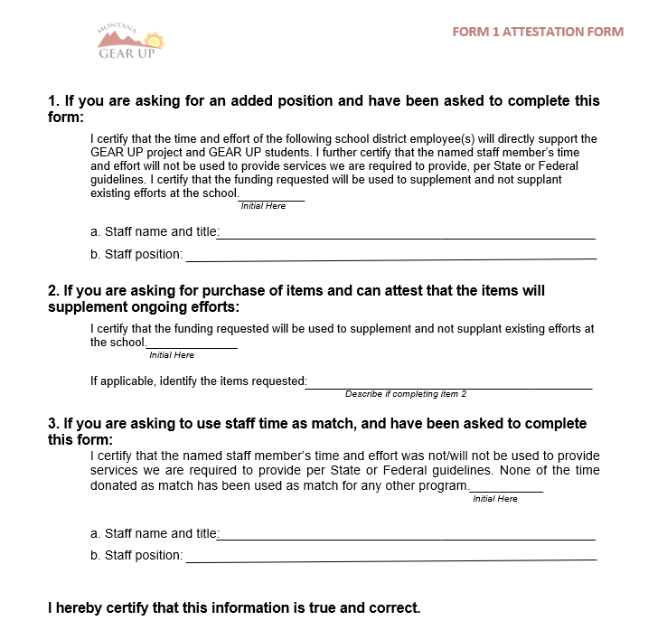

Form 2 Return on Investment (Excel):
A required document used to justify the reasonableness of purchases that are needed but not tied into a service. For example, computers used in regular classroom are needed, but not tied to a service. Use this as needed during annual planning and during amendments. Excel Forms have blue cells to complete.
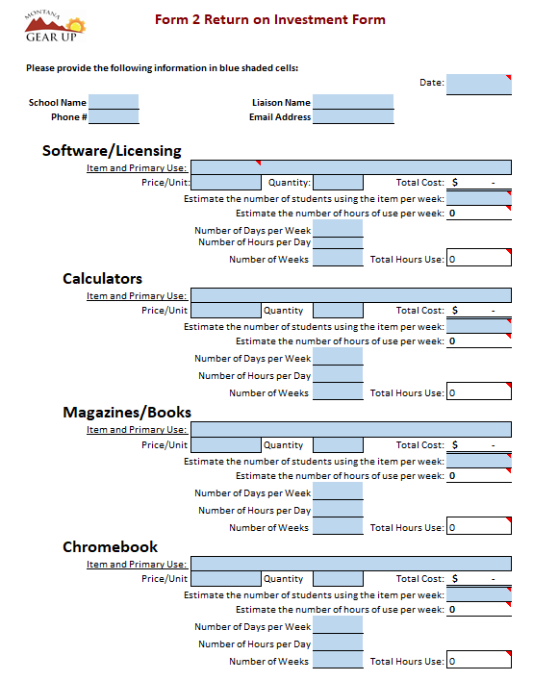

Amendment Request Forms
There are two versions you may use depending on your preference (e.g. Excel or Word).

Form 3A Amendment Request (Excel)
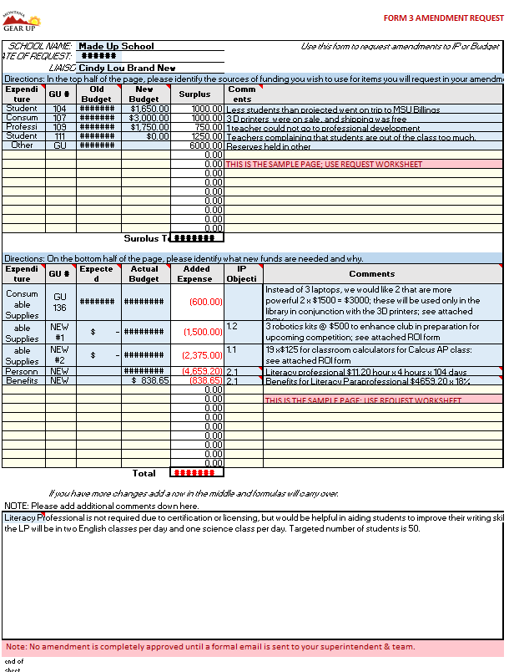

Form 3B Amendment Request (Word)
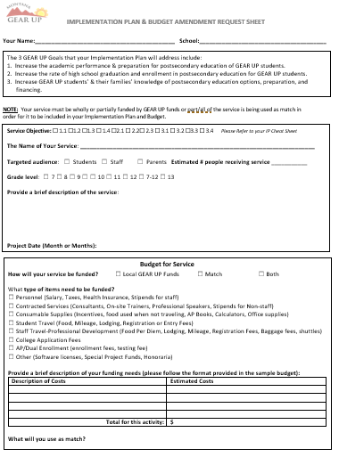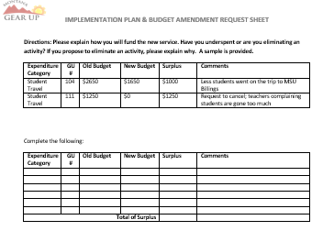

Forms Used When Providing Services to Verify Attendance:
Sign In Sheets offer proof of attendance at services (which verifies reasonableness of expenditures and tracks number of hours per individual). Examples include parents signing in at a dinner shows reasonableness of amount of food purchased, or students signing in each day when they receive tutoring, shows the service is happening. A copy of attendance sign in sheets should be kept in the service documentation folder. You will need one sheet per subject for tutoring.

Form 4A Tutoring Sign in Sheet (Word)
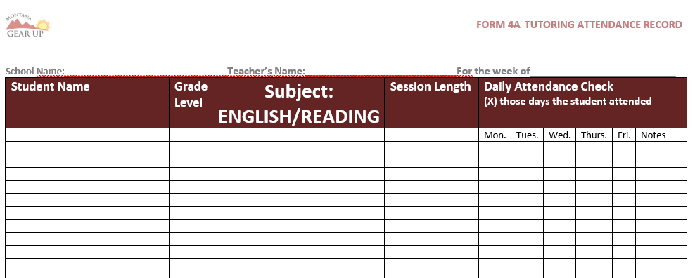

Form 4B Event Sign In Sheet (Word)
Form 4B is used as a sign in for dinner during parent teacher conferences. It shows the reasonableness of amount of food purchased. Make and use forms like Form 4B for each event, including campus visits.
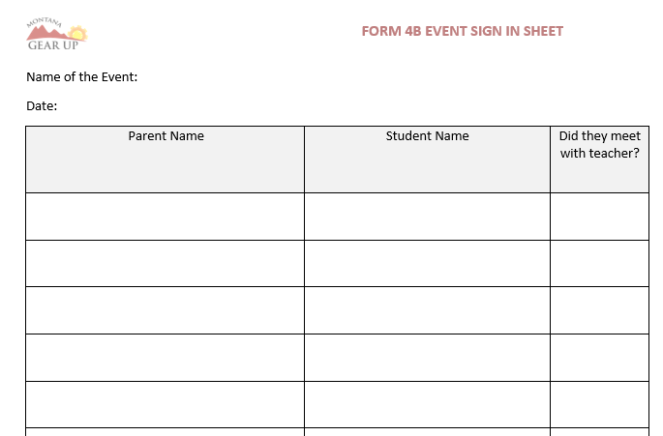

Form 4C Summer Attendance Record (Word)
Used to record services during the summer months. Student data from summer months must be entered into GEARS by August 15th. Summer Services must be entered into GEARS by the first Friday in August.
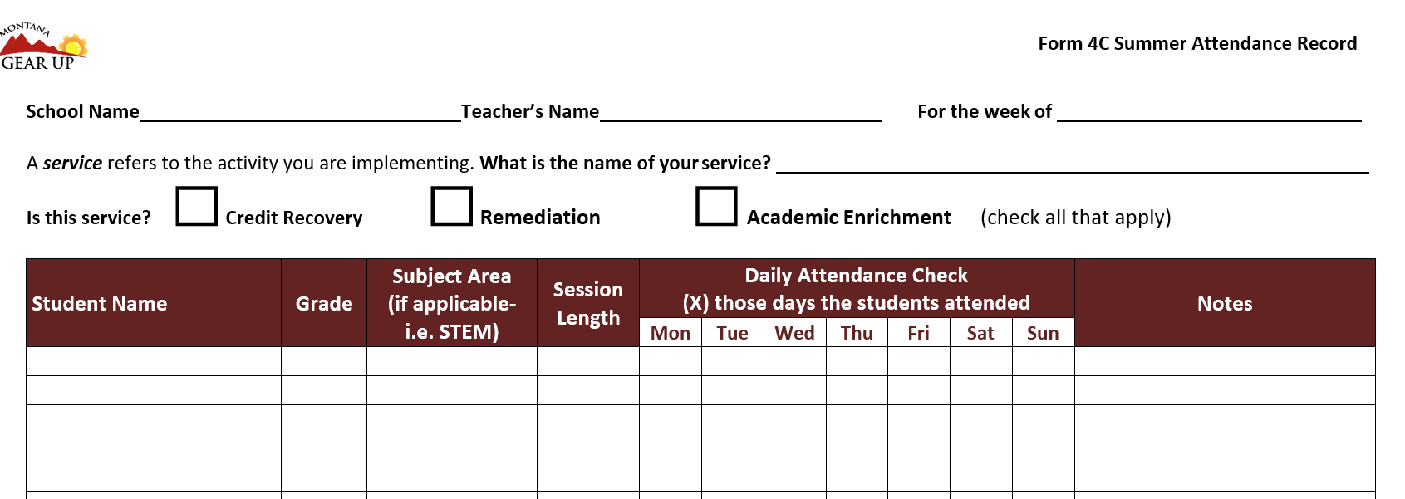

Forms Used for Fiscal Reporting:

Form 5 Time and Effort Certification (Word)
Used by school staff whose salary, or part of it, is written into the local GEAR UP budget, the document certifies that the hours were worked. Liaisons, tutors, and others will need to submit certifications.
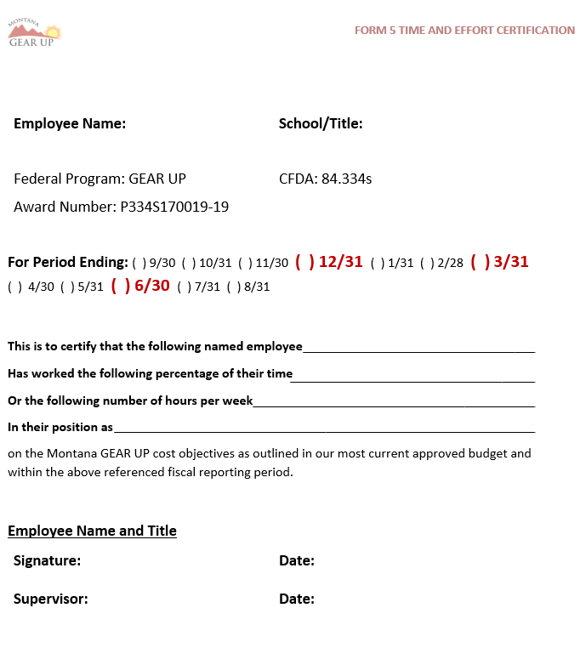

Form 6 The Fiscal Report (Excel)
Every school will turn this form in with a Quarterly Report and Final Summer Report. The Federal Accountant provides it at the beginning of a grant period.
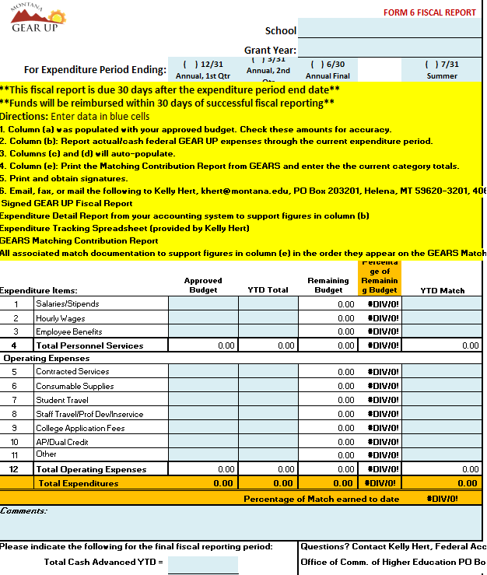

Budget Tracking Sheet (Excel)
Used by the liaison to track expenditures to be charged against the grant. It must be reconciled with the Clerk’s record. Use will identify items that should not be charged against GU because they were not in the GU approved budget. This report is pulled by the Federal Accountant from our GEARS database and is sent to you at the beginning of each grant period. It is suggested you save a copy and add every expenditure you know of into it as the expenditure occurs, then use a second copy during your report that reflects what has cleared the leger during the reporting period.
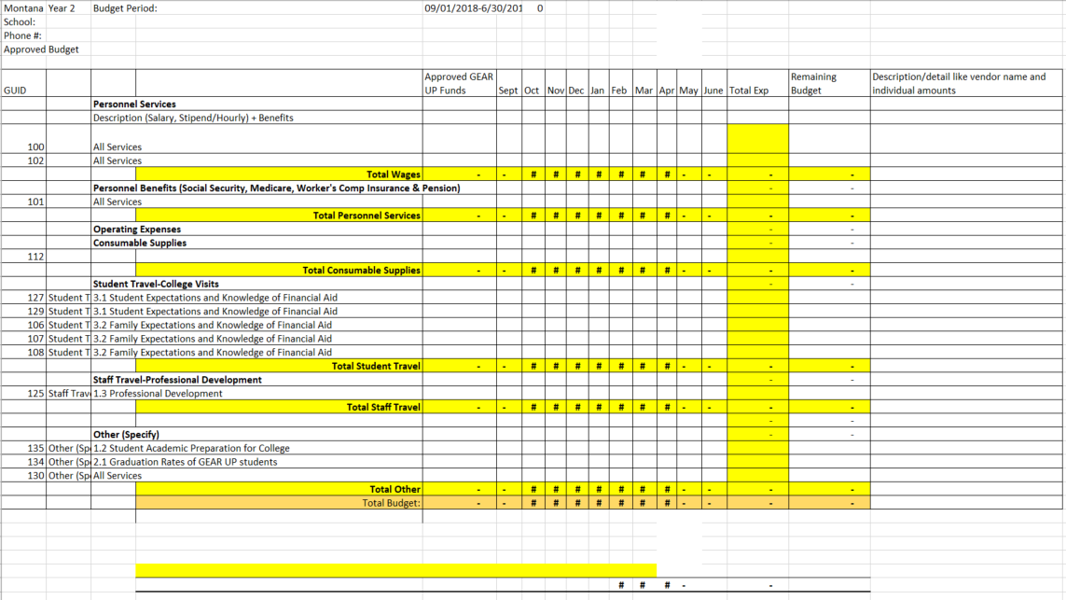

Forms Used for Establishing Match

Form 1 Attestation (Word)
Used when a school wants to document an employee’s time as match this offers attestation that match is not being counted as match for another program and that the services were not required by State or Federal guidelines. This form must be signed by the school Superintendent or designee.

Form 7 In-Kind Matching Report (Excel)
Used when a single individual’s time, travel, or physical donation is offered as match. For physical donations a receipt is best to show the evaluation. If no receipt is available, the value must be fair market, as in the example. A photocopy of hotel receipts should be requested.
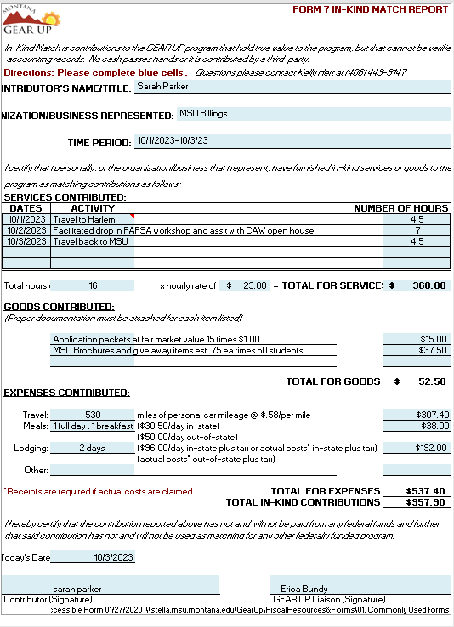

Form 8 Facility and IT Maintenance Match (Excel)
The first tab on this form captures the value of the space, utilities and custodial costs being provided to hold GU activities. For both tabs, the match is the actual costs paid during the reporting period (i.e. monthly or quarterly). Please Note: These forms merely calculate the value; back up documentation must accompany them.
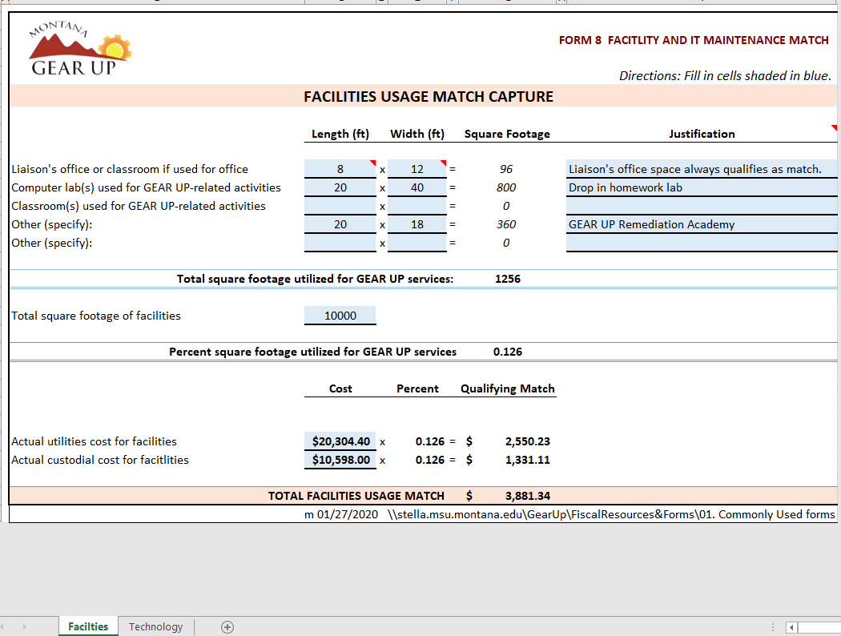
The second tab of the Excel spreadsheet covers the value of the IT resources, as well as the cost of upkeep, and operating costs of the IT department being used for GEAR UP activities. The number of GU students is the number in your current cohort; staff refers to paid GU staff. See TAM Section 3 for back up documentation.
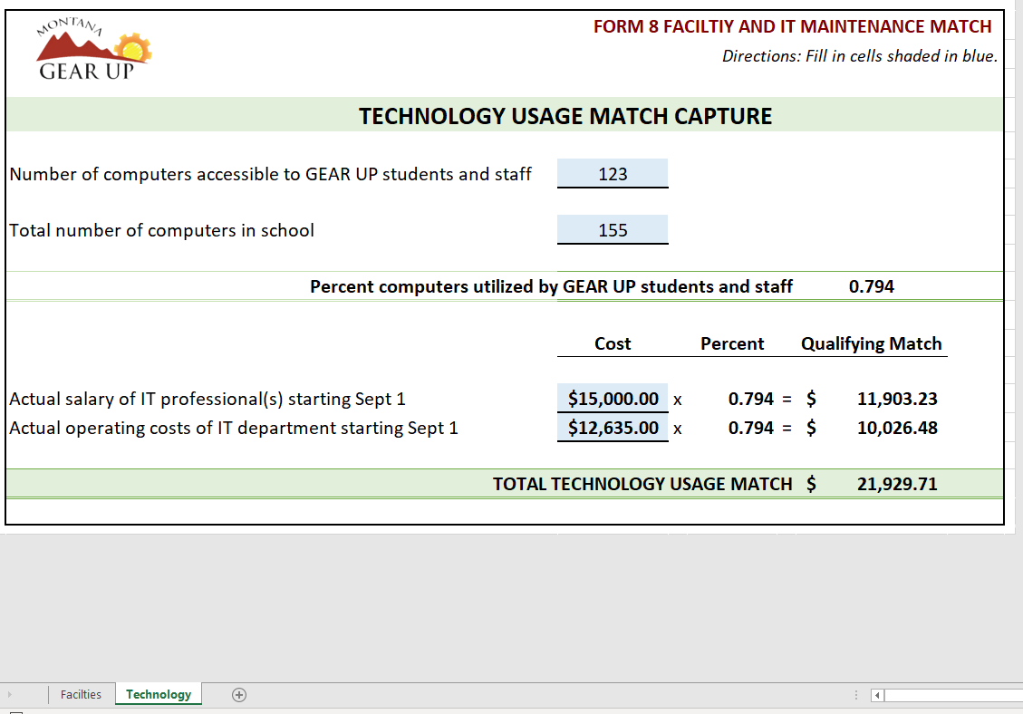

Sign-in Sheets Match
These forms are good for when you have a group of people who are volunteering to host a GEAR UP event. You can pass this form around and have many people sign it, to record their hours. There are two versions of the volunteer match form.

Form 9A Sign In Match Sheet (Word)
Actual Rate: this form is for when you have staff (the school’s) that are willing to record their actual hourly wage. This form is intended for use during a onetime event.

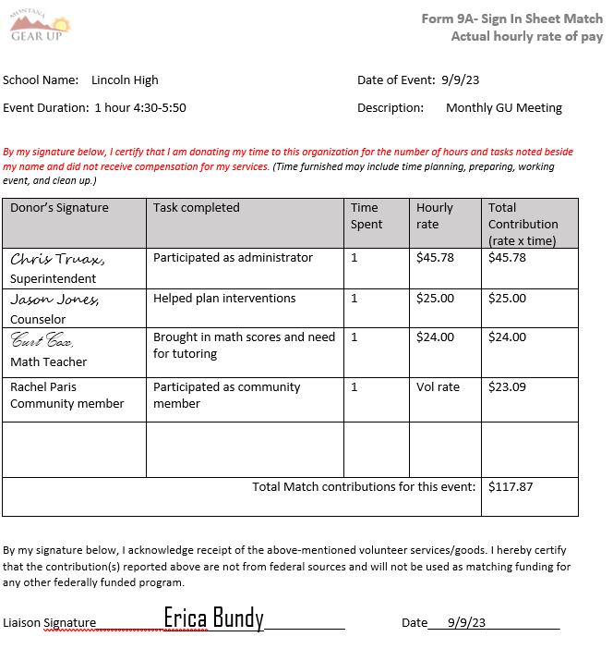

Form 9B- Sign In Match Form - Volunteer Rate (Word)
is used when you have parents or professionals from other organizations volunteering and you can’t assign a wage to their effort. You can estimate by using the annual volunteer rate. (The rate changes annually so the current rate may not be reflected in this sample.)
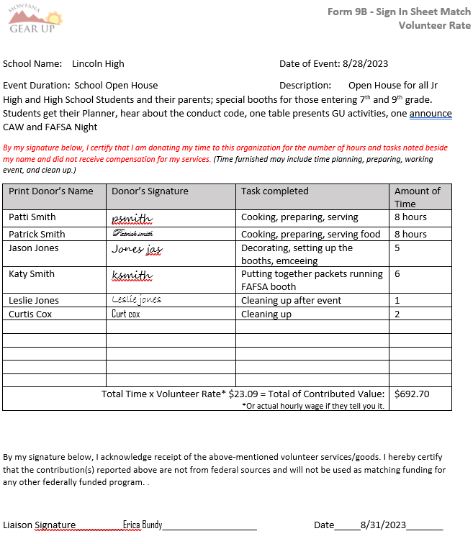
6 hours

Form 10 Time and Effort Match (Excel)
Most likely used by administrative staff (Superintendent, Clerk, Principal) while they do activities that directly support GU. They can count their time during the contract day. Teachers and counselors who assist on a regular basis with GU activities beyond their contracted day, can use this form, if no hours during the contract day are counted. Note: Choose the Second Tab.
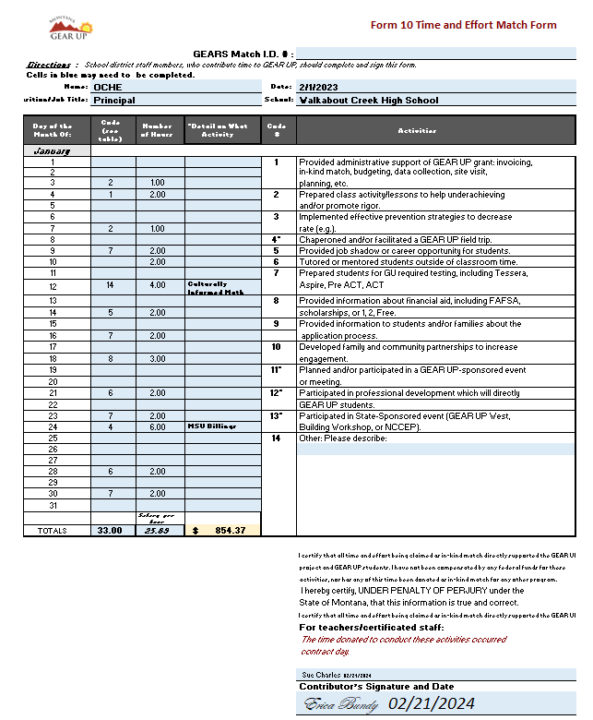

Forms Used for Travel

Form 11A District Reimbursement form for Travel (Excel)
Will only be used following State-sponsored travel (meaning it is not in the local budget). For example, when you apply to go to a conference, are selected, and then go. Upon your return this form is your request for reimbursement of food (per diem) and ground transportation. You may use your school’s travel reimbursement forms, if they follow the current year’s reimbursement rates for per diem, and mileage reimbursement. (This image may not have the most current rates.)
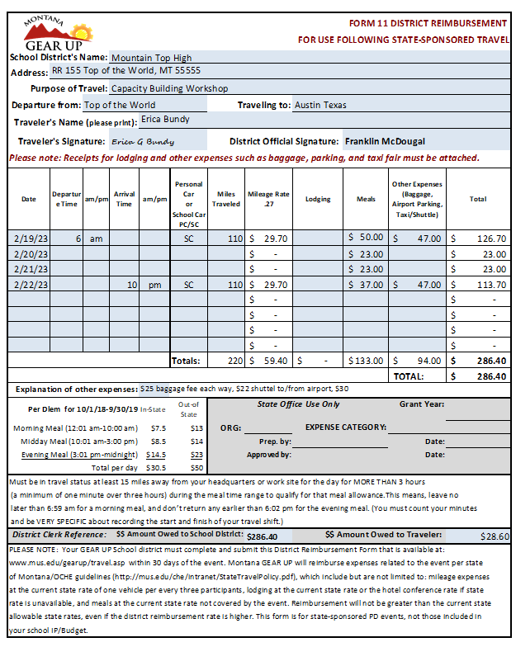

Form 11B Student Travel Voucher (Word)
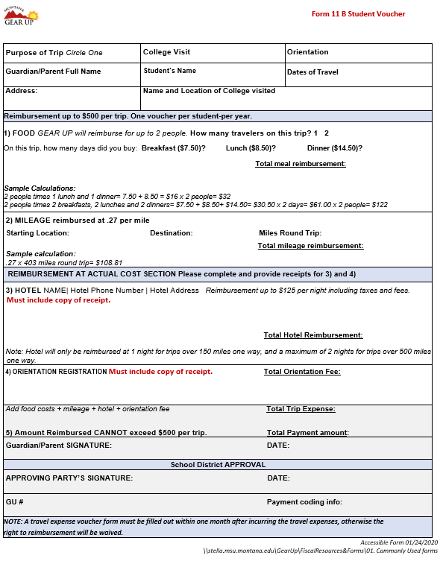

Forms Used for Local Team Meetings

Form 12 Local Team Meeting Agenda (Word)
This form is designed to help a local team stay on task, so the Implementation Plan and all associated administrative tasks are fulfilled.
