Description

The central objective of the MUS Resident Student Access Initiative is to deliver the promise of higher education to more Montanans. Through a unified and central approach, the Office of the Commissioner of Higher Education (OCHE) is (1) improving awareness of the value of higher education through the development of a College and Career Access Portal and (2) removing barriers that limit access by providing a single free application to all MUS institutions through Apply Montana (ApplyMontana.MUS.EDU).

Central Application for Montana (CAS)
- Through the MUS Central Application, Montana resident students can complete ONE application and apply to all 16 campuses within the MUS for free.
- MT is currently one of only a handful of states with a central application led by a system office that offers a free option to apply across all public higher education campuses.
- Since 2020, More than 25,000 applications have been started/and or submitted through the central application.
- The central application has contributed to a record number of new college applications to the Montana University System, removed significant cost barriers for low income families by providing it at zero cost to Montana residents, and reduced the time needed to apply by completing a comprehensive review of previous application formats while disseminating these benefits across all campuses in a shared services model.

Apply Montana Resident Student Access Portal
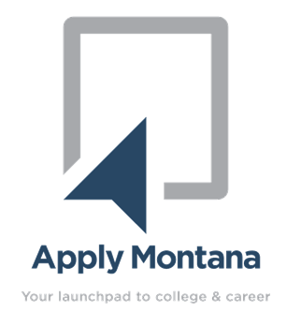
- Launched in March 2022 a standalone resource, the Apply Montana Resident Student Access Portal (applymontana.mus.edu) is a dedicated resource that provides customized information about higher education opportunities and career paths to Montana’s students, parents, and educators.
- Key focus areas:
- Career exploration and expanded MT workforce data provided by the Department of Labor and Industry;
- Financial resources to assist families with the cost of higher education;
- Information on how to prepare for college; and
- Exploration of the types of degrees and colleges available through the Montana University System.
- The MUS central application is housed on the portal website, allowing students to not only submit their application to the MUS, but also have access to the additional resources provided in one convenient location.

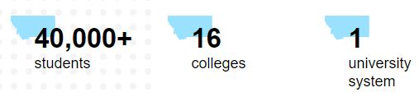
MUS Strategic Plan
- Success Agenda Goal No. 1 (Resident Student Access)
- Success Agenda Goal No. 8 (Shared Services)
- Success Agenda Goal No. 9 (Communication & Advocacy)

