Dual Enrollment in the MUS
Highlights

- Dual Enrollment provides opportunities for high school students to take college courses while still in high school.
- Students take Dual Enrollment courses for either Dual Credit or College Credit Only.
- Dual Credit courses award high school and college credit simultaneously for the same course. College Credit Only courses award college credit (and not high school credit) for a college course.
- Montana University System colleges and universities offer Dual Enrollment courses via two delivery models: Early College and Concurrent Enrollment.
One-Two-Free

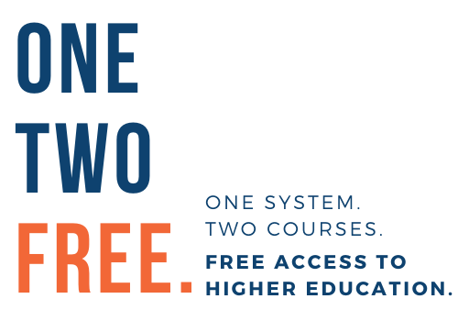
- One-Two-Free offers two dual enrollment courses, or up to six credits, through the MUS to all eligible students for FREE.
- One-Two-Free launched in August 2018 as a pilot program funded by the MUS to increase access to higher education for high school students, reduce education costs for Montana families, and enhance student success.
- One-Two-Free also allows students who demonstrate hardship to apply for a scholarship to cover tuition for additional Dual Enrollment courses.
Dual Enrollment Data

