**Description**

Montana 10 enhances the state’s skilled workforce by dramatically increasing the number of Montanans who have two-year and four-year degrees AND does so at a lower cost per degree for Montana taxpayers.

**Highlights**

**DRIVES DEGREE COMPLETION** Montana 10 increases graduation rates by leveraging predictive analytics, system-level policy, and an incentive-based model that ties financial incentives to key academic, advising, and career development supports.

**ENHANCES EFFICIENCY FOR STUDENTS AND THE STATE** Montana 10 shortens time to degree, reduces student debt, and increases completion rates—all at a lower cost per degree for the state.

**INCREASES OPPORTUNITY FOR ALL MONTANANS** Montana’s low-income students are nearly twice as likely as their middle and high-income peers to drop out with some college, no degree, and debt. Montana 10 dramatically increases the likelihood that rural, low-income, American Indian, and other underserved Montanans can earn a college degree.

**PREPARES MORE MONTANANS FOR A SECURE FUTURE** A greater share of jobs paying over $50K go to two- and four-year college degree holders. Montana 10 gives more Montanans the chance to secure a good job for themselves and their families.

**Proven Outcomes**

**MORE STUDENTS STAYING IN SCHOOL & GRADUATING** After two years of a 200- student pilot project, the program has produced an **18% increase in retention for four-year students** and **doubling on-time degree completion for two-year students** compared to peers not in the program.

**Fall ’20 to Fall ’22**

**Retention**

**MT10**

**PELL**

**All Other**

**62%**

**63%**

**44%**

**MAKING BETTER PROGRESS TO ON-TIME COMPLETION** Montana 10 students earned 6 more credits in their first year than their low-income peers, putting them on track to graduate a year earlier, **making their degree less costly to themselves and the state.**

**CHANGING BEHAVIORS TO DRIVE SUCCESS** Montana 10 students are more than **2x as likely** as their peers to talk to their advisor about **career planning**, **4x** as likely to get help accessing campus services like **financial aid and tutoring**, and **7x** as likely to talk to an advisor about **mental health**.

*“The most valuable part of Montana 10 has been the advisors and outreach,* ***I always felt like I mattered, and my problems were addressed and listened to****.”*

Montana 10 Scholar,

University of Montana

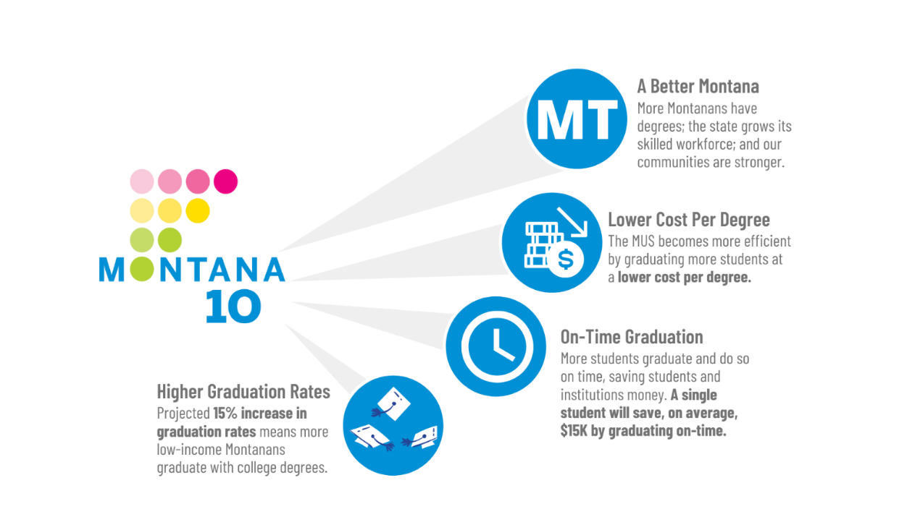

**+ Success Agenda Goal No. 6** (Resident Student Success)

**+ Success Agenda Goal No. 3** (Retention)

**+ Success Agenda Goal No. 7** (Performance-Based Funding)