Highlights

- To leverage collective assets and to meet the needs of tomorrow’s tech fluent and highly adaptable students, the Seamless System Initiative has two aims:
  - create a seamless online course catalog for students to discover, register for, and access all online courses across all campuses in the MUS; and
  - provide a seamless digital learning environment for all students and courses that will modernize and improve the quality of service and create a single, consistent digital learning environment across the MUS.
- Together, the single course catalog and single learning management system (LMS), will create a cutting-edge, mobile-friendly, and engaging user interface for all current and potential students across Montana.

Single Online Course Catalog

- Providing a single catalog of all courses available online in the MUS will create a one-stop-shop for students to discover, register for, and access all online courses available in the MUS, regardless of a student’s home campus or physical location.  - Through a partnership with Quottly, an industry leader for course discovery platforms, the MUS can offer a cutting-edge platform for students while reducing administrative challenges for campuses and staff.  - A single catalog of online course offerings will eventually include dual enrollment courses to popular transfer courses and workforce training programs. | 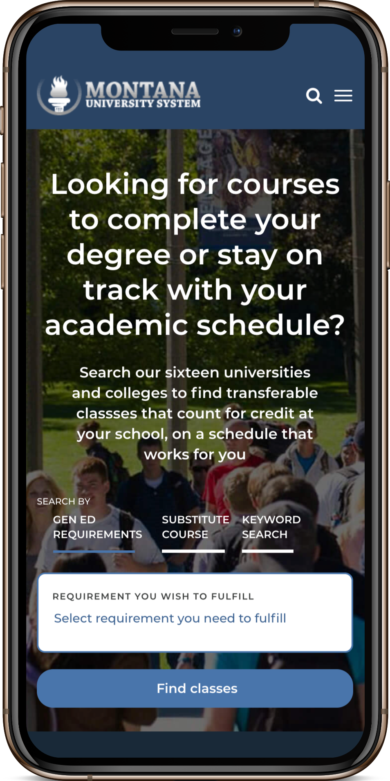
- Fully developed, an integrated online course catalog for the MUS will triple or quadruple the number of courses available at smaller MUS campuses.

Single Learning Management System (LMS)

- A single Learning Management System will modernize and improve the quality of service for students and create a single, consistent digital learning environment across all campuses.
- As two sides of the system, UM and MSU, use separate systems for student learning management. UM uses Moddle, and MSU uses D2L/Brightspace. Both platforms have received mixed reviews from students and faculty.
- Separate platforms operate as an artificial barrier between UM and MSU and serves to further silo student learning environments, impede transfer pathways, and reduce options for shared programs.
- A centralized LMS will eliminate these “digital silos,” provide cost efficiencies, and better serve students.

MUS Strategic Plan

- Success Agenda Goal No. 1 (Resident Student Access)
- Success Agenda Goal No. 3 (Retention)

