Montana’s Workforce Development Engine
Highlights
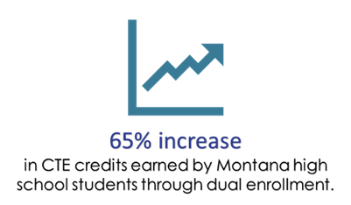
- More than 80% of Montana’s University System resident student graduates join Montana’s workforce.
- Over 1,000 MUS students graduate with degrees in health professions every year.
- Each of the MUS 16 campuses delivers high quality, hands-on, and innovative trades and technical education.
Public-Private Partnerships

- Montana’s Two-Year and Community College Campuses partner with private business and industry partners to strengthen community workforce pipelines. Highlights include:
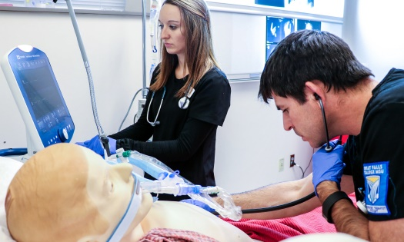
  - Helena College and Boeing
  - Missoula College and ATG Cognizant
  - Gallatin College and Bridger Aerospace
  - Great Falls College and distance-education partnerships with local healthcare providers around the state
  - Montana State University Northern and Accelerated Apprenticeships in Electrical and Plumbing, serving businesses in several locations across Montana
  - Dawson Community College and Stortz Angus Ranch
Serving All Montanans

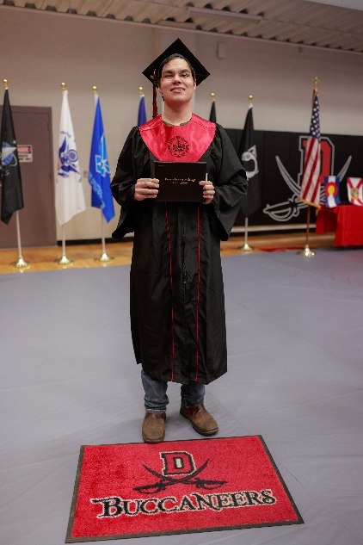
- American Indian students comprise nearly a quarter (23%) of all postsecondary Career and Technical Education student concentrators served by the Carl D. Perkins Grant in Montana.
- The Montana University System has prioritized innovative delivery methods for Career & Technical Education programs in order to provide needed training and education opportunities to students in every community. Opportunities include:
  - University of Montana Western’s Online Teacher Certification, helping solve teacher shortages in rural Montana
  - Miles Community College partnered with the Montana Farm Bureau and the Montana Meat Processors Association to address critical workforce shortages using an innovative “hub and spoke” model
  - Great Falls College expanded the AAS degree program in respiratory therapy via distance-education and partnerships with other colleges and local healthcare providers

