The following are screen shots from the new central Montana Application, Apply Montana. These are taken from the “test” application.
One main point to highlight is the application is FREE for all Montana residents. However, the application will tally the cost of each application to each institution as you go. (Shown below) The total will be zeroed out at the checkout.
- Here we have applied to three schools (2 shown). You will notice the green line is almost complete. At this point, students need to click “continue to my application”.
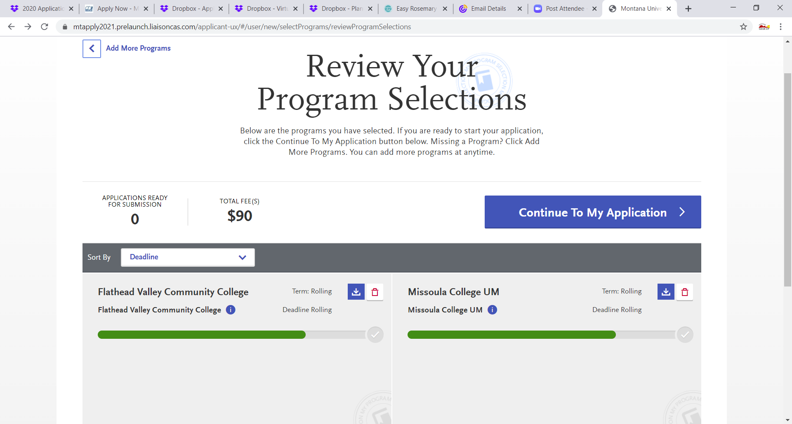
- Once the student clicks “Continue to My Application”, they will want to finish the final quadrant (shown below). This quadrant will vary depending upon where the student intends to apply. Example: MSU-Billings will have different questions than Helena College.
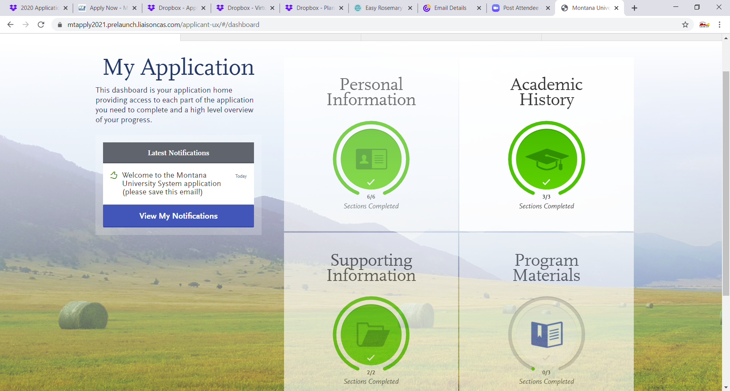

- Once the student clicks on “Program Materials”, each school they are applying to will populate on the left side. As stated previously, each school will ask different questions of the student. Most are centered around start date, program of study and personal interests. Students will want to click the questions tab to complete for each school.
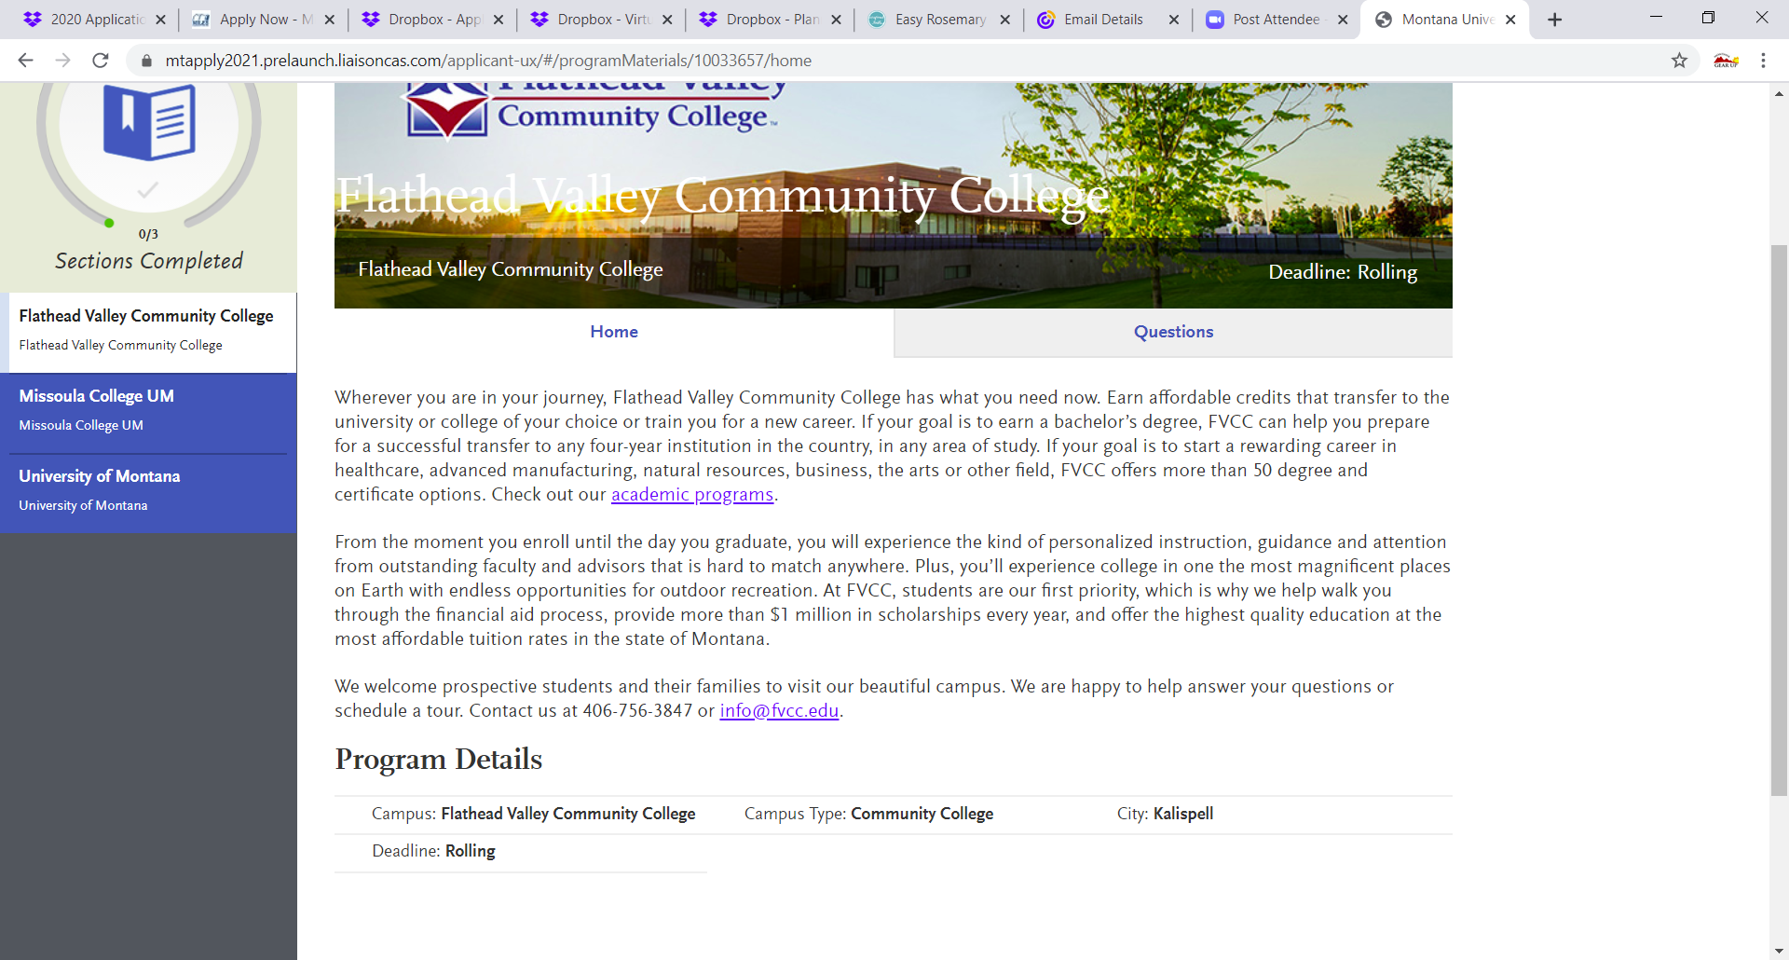

- Once the questions for the school are complete, there will be a green checkmark. Student will then want to click their next school. It will not automatically rotate to the next school. Continue completing the additional questions for each campus.

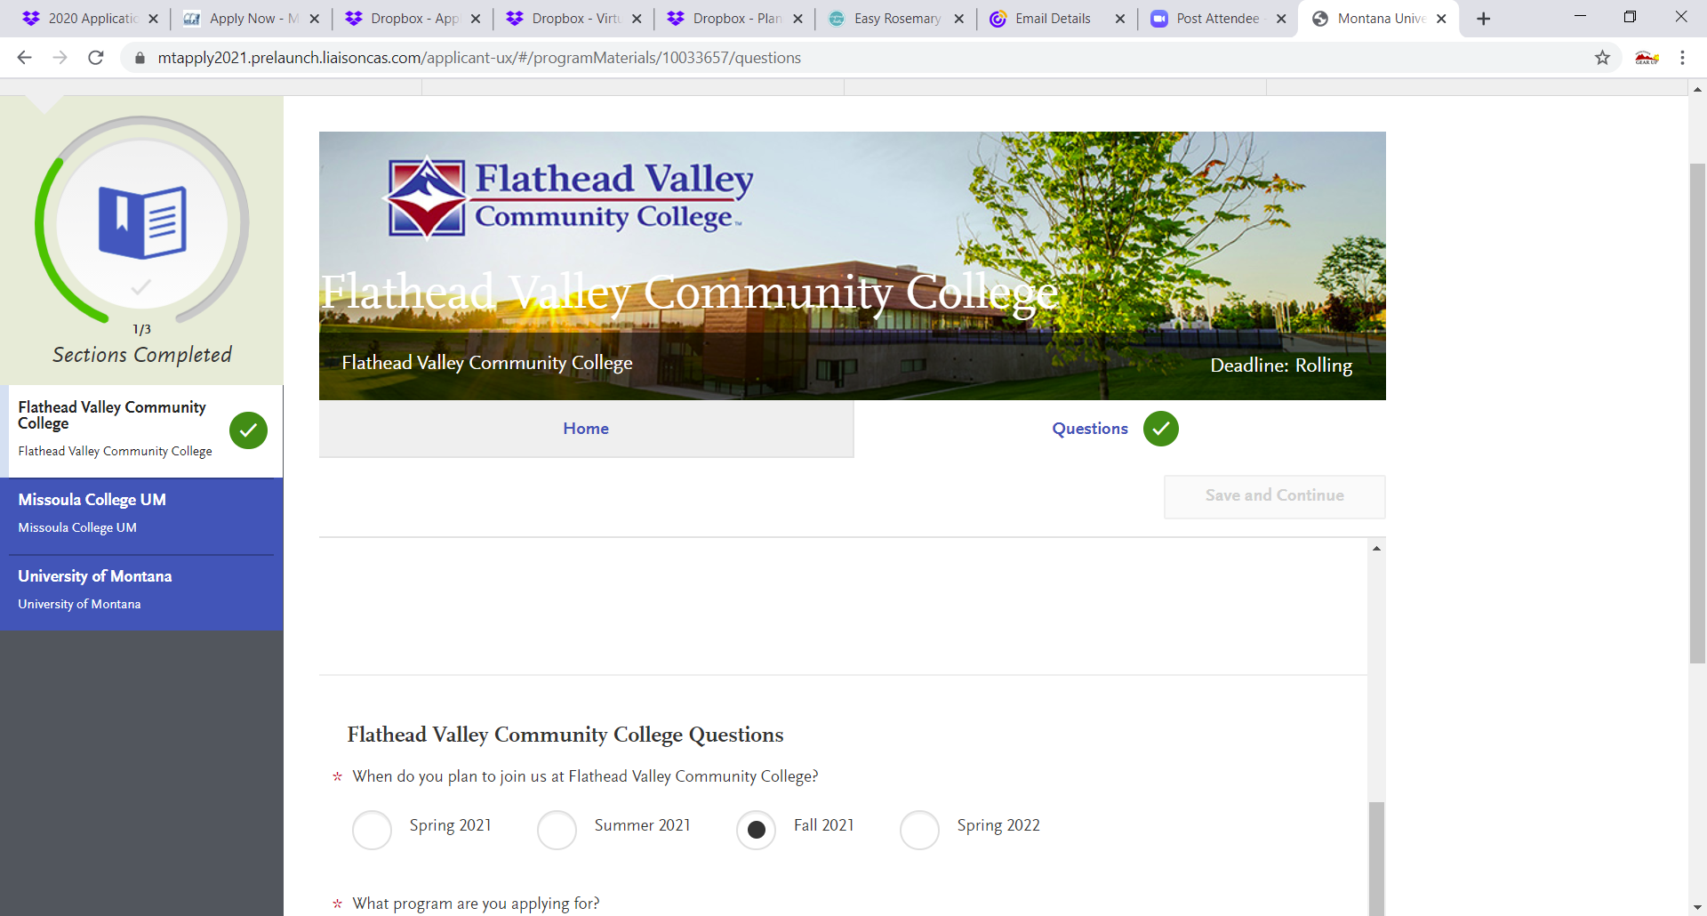

- When all schools have checkmarks, students will want to select “Submit Application”.

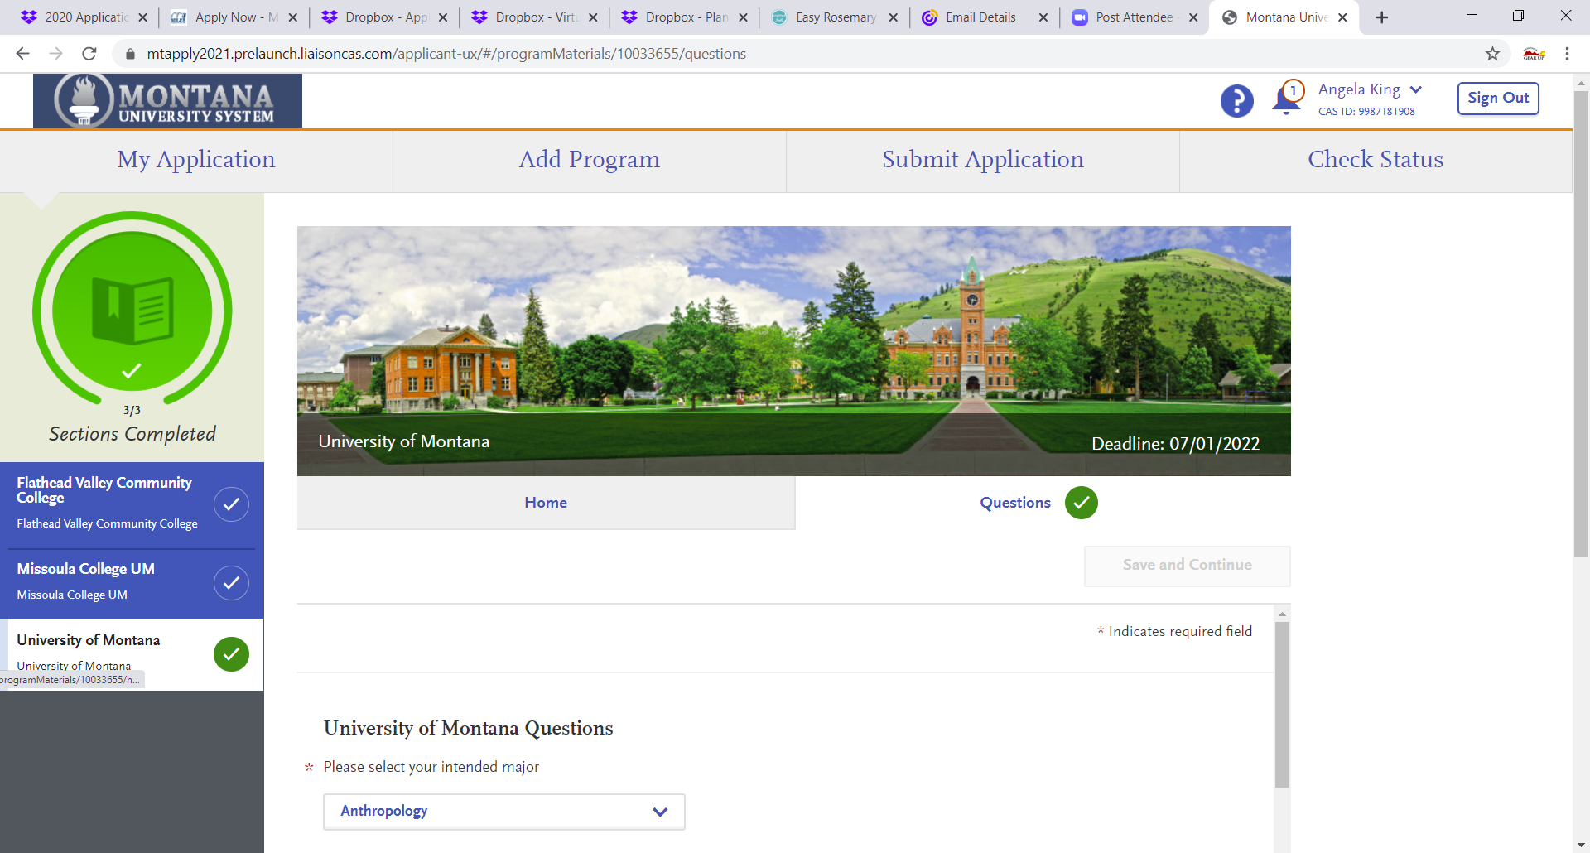

- Once in the “Submit Application” tab, students will see all green lines complete, the number of applications ready for submission, and again the cost will be shown. Please remind them, this will zero out. Click “Submit All”.

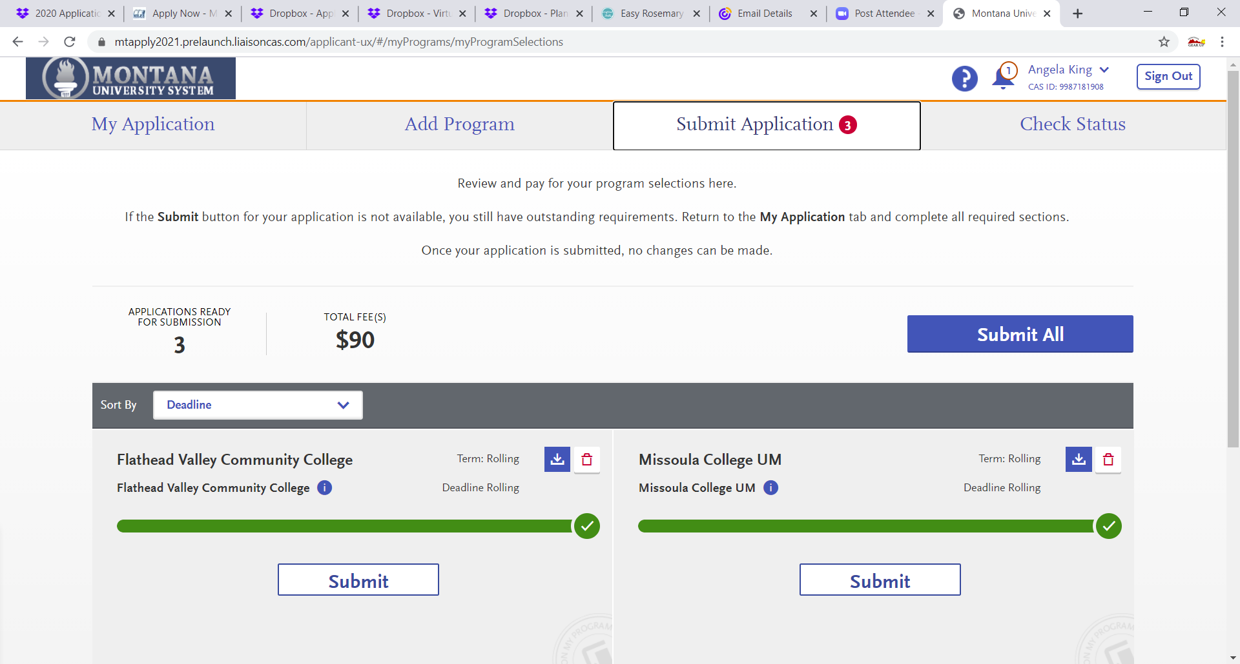

- Once they click “Submit All”, they will see this screen. It will list all the schools they selected and the zeroed-out totals. Click “Continue”.
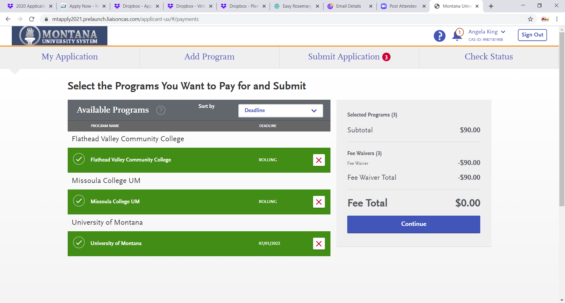

- The following screen will show their confirmation of submission and no charges! The final tab across the top will eventually show a student’s application status once their applications have been processed.
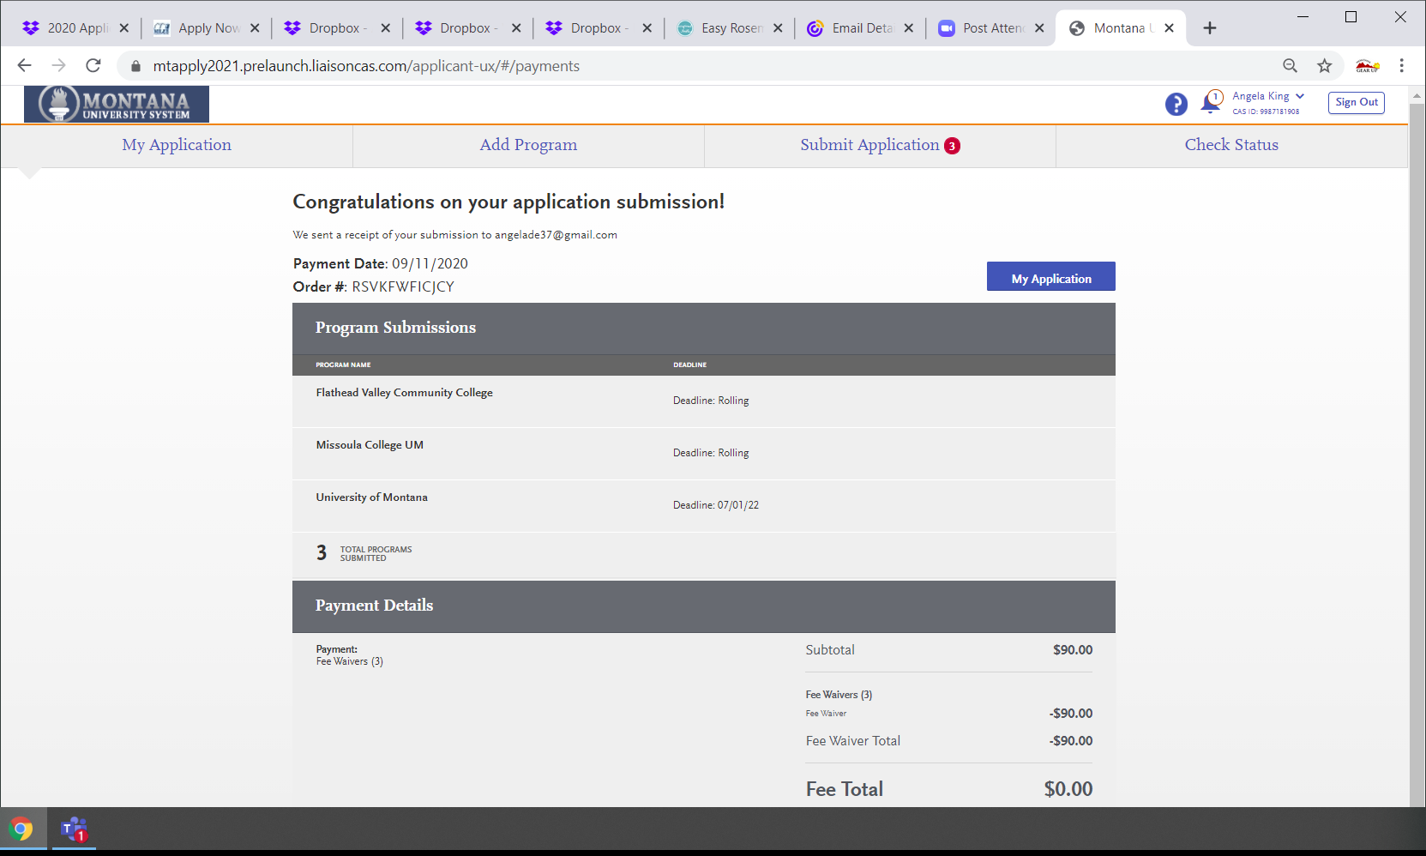

Things to Remember:
- Applications are only free for Montana Residents.
- If the student’s bill is not waived at the end, they most likely did not answer a resident question correctly. Encourage them to go back and check their answers on the application.
- Students/families/counselors can always reach out to our Help Center
  - muscas@liaisoncas.com or 617-702-4926

Thank you!!

