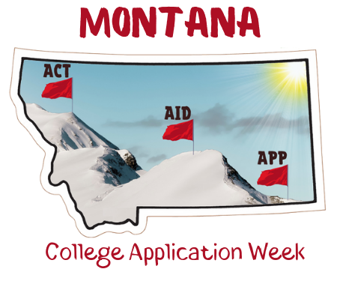
Event Day Reminders

This checklist offers essential reminders for a successful College Application Week event, including those that will enable you to fulfill your obligations to the CAW steering committee. You may find that there are other tasks to complete on the day of your site’s event. Feel free to add rows as needed.
Event Day(s)
Status | Task | Notes
 | Turn on all computers with your preferred web browser.
 | Post required school information (mailing address, phone, CEEB code, etc.) in each computer lab or classroom where students will be completing online applications. Students may need to reference this information when completing applications.
 | Greet volunteers, provide them with a nametag, and give them a job to do.
 | Have seniors sign in as they arrive. A sample sign-in sheet is available on the website, but we strongly urge you to print a list of all seniors’ names and birth dates to use as a sign-in sheet. YOU WILL NEED THIS DATA TO SUBMIT TO THE STATE COORDINATOR.
 | Distribute the “I Applied … Now What?” handout. (Download extras from the website.)
 | Be sure that when students complete and submit their application(s), they print confirmation page(s) or save their application(s) for final work within the next day or two.
Before students leave, ensure they do the following:
- Complete the Student Survey on the CAW website
- Review the “I Applied … Now What?” handout
- Collect the#iApplied bracelet to celebrate their participation in CAW.
 | Complete the Site Coordinator Survey and submit your data. You will need: number of seniors enrolled, number of seniors who participated, number of applications in-state, number of applications out of stae.

