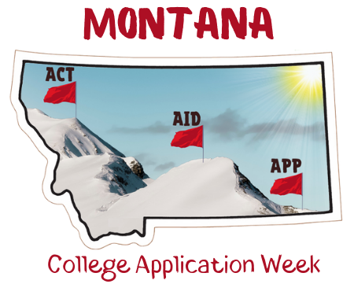
Montana College Application Week
Paper Application Cover Sheet

- Make copies of this cover sheet for each college to which your students are submitting paper applications.
- Enclose the original completed paper applications with this cover sheet and mail them directly to the college immediately following your event(s).

Enclosed are paper applications to _______________________________ completed by
(Name of College)
students at _________________________during 2023 Montana College Application
(Name of High School) Weeks October 2-13, 2023,

Total number of applications enclosed: ________

Site Coordinator Name: _______________________

Date: ________________________________________

Phone Number: ______________________________

Email address: ________________________________

